**Year 2 Newsletter**Autumn 1 Term

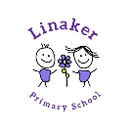

**Units of learning this half term:**

English – In writing the children will be learning how to write a circular narrative using the text A River to inspire their thinking. They will also learn how to write a letter inspired by their travels along the river.

Maths – Place value / Addition and Subtraction

Science – Everyday Materials

P.E. – Fundamentals and Ball Skills

PSHE – Being me in my world.

Art – Explore and Draw

History – The Great Fire of London- How did it start? What lessons have been learnt?

**Books we are reading:**

Linaker English –

A River

**Reading for Pleasure –** Children to have access to books from class and school library to read in the school day/ at home.

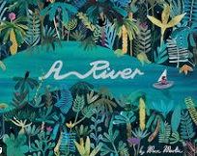

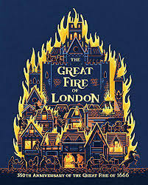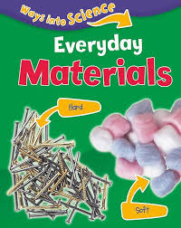

**Home learning:**

Daily Reading

Top marks (maths online programme)

Times Table Rockstar

Year 2 spellings

**Useful websites:**

<https://www.topmarks.co.uk/>

[www.getset4education.co.uk](http://www.getset4education.co.uk)

<https://ttrockstars.com/>



|  |  |  |
| --- | --- | --- |
| **Weekly reminders for Year 2** | | |
| **Monday** | PE day |  |
| **Tuesday** |  |  |
| **Wednesday** | PE day |  |
| **Thursday** |  |  |
| **Friday** | Reading books to be changed in school |  |

Some important reminders:

* Please ensure children are bringing a water bottle to school every day.
* Reading books to be brought to school every day for reading.
* Correct uniform is required.
* Earrings to be removed for PE days.
* Please make sure that all your child’s uniform including PE kit and coat, is clearly marked with their name. Clothing is easily misplaced or mixed up.
* No big bags please.
* The weather will begin to get wet, cold and unpredictable so please remind children they need a coat in school.

**Your Year 2 Team**

Teachers

Mrs Parr 2G

Mrs Williams 2F

Support Staff

Mrs Wright

Mrs Rimmer

