**Nursery Newsletter**Autumn Term 2024

**Units of learning this half term:**

We are so excited to have welcomed our new children in to Nursery, and to see our children from last term return. We have lots of exciting learning planned.

In maths, we will be joining in with number rhymes to 5 using props and our fingers. We will use some number names in our play and recite numbers to 5 in the correct order.

Phonics in nursery begins with Phase 1 Environmental Sounds. We will be listening to environmental, instrumental and other sounds and distinguishing between different sounds.

**Books we are reading: Our first book focus this year will be Happy To Be Me by Emma Dodd.**

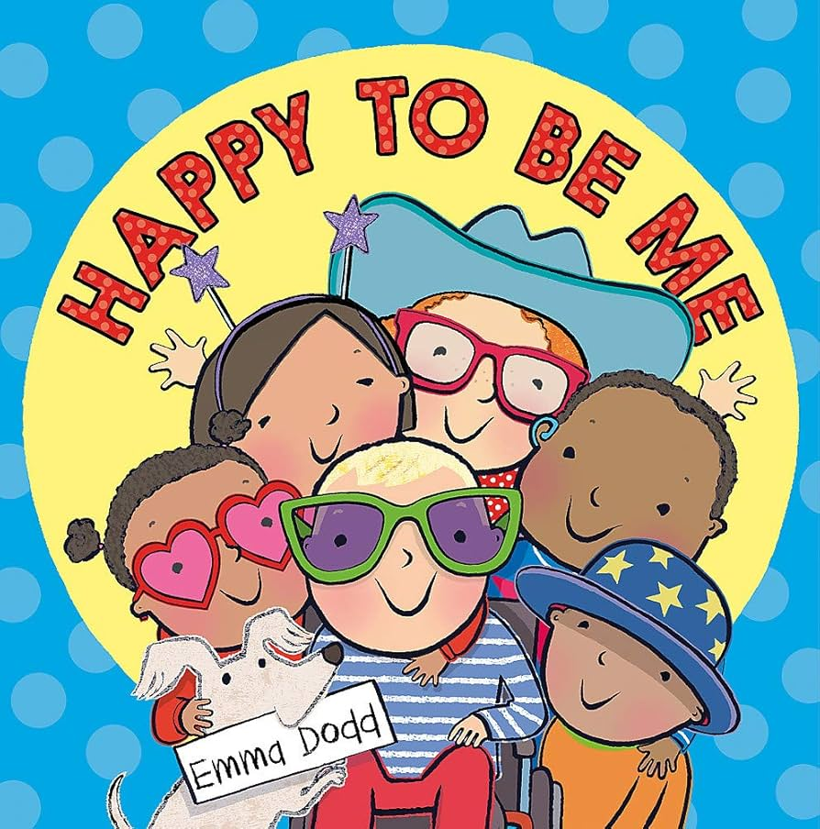 

This story, along with Amazing Me and Heads, Shoulders, Knees and Toes, will help us to think about who we are, where we belong and all of the things that make us, us!

We will be busy bees as we explore our new environment, share our interests and make independent choices.

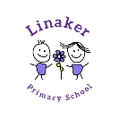

**

**Home learning:**

Your child will be bringing home a library book each week for you to share together at home. Please try to read it together at least 3 times each week. Books are changed weekly.

|  |  |  |
| --- | --- | --- |
| **Weekly reminders for Nursery** | | |
| **Monday** | £1 snack |  |
| **Tuesday** |  |  |
| **Wednesday** |  |  |
| **Thursday** |  |  |
| **Friday** | Reading books changed |  |

**Some important reminders:**

* Please ensure **ALL** uniform items are **clearly labelled** with your child’s name.
* Snack money is £1 per week or £7 for the half term.
* Children should bring in a water bottle each day.
* As the weather turns cooler, please ensure children are dressed appropriately with a coat. We are outside in all weather!
* If you need to speak to your class teacher, please arrange an appointment at the school office for a mutually convenient time.
* For safety reasons, we ask parents to refrain from walking up the ramp at home time. Please wait at the bottom of the ramp for your child to be called by a staff member and sent out to you.

**Dates for your diary:**

INSET Day – Friday 25th October

Half Term – 28th October to 1st November

