**Year 1 Newsletter**Autumn 1 Term

**Books we are reading:**

* The More it Snows
* I do not mind you Winter Wind
* Hey Little Ant
* The Trouble with Trolls
* Peace at Last
* Major Glad, Major Dizzy

Our focus author is Oliver Jeffers so we are reading lots of books he has written.

**Units of learning this half term:**

English – finding narratives (Major Glad, Major Dizzy)

Maths – Place value to 10 and +, -, =.

Science – Humans

P.E. – Ball Skills & Fundamentals

PSHE – Being in my World

History – My Family History

Computing – Computing Systems & Networks

Art – Using our whole bodies to make drawings

RE – Who is a Christian?

Music – Hey You!

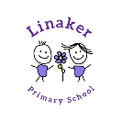

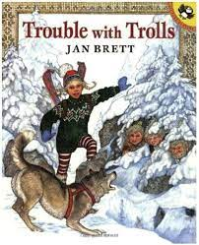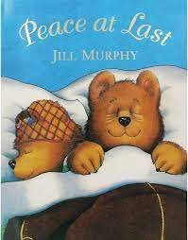

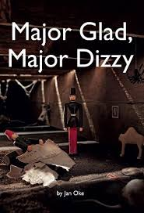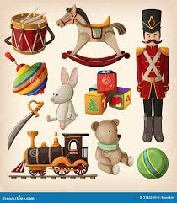

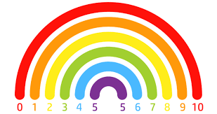

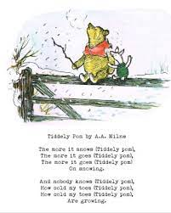

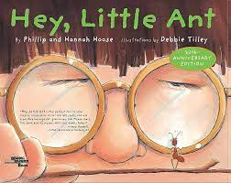

**Home learning:**

**Each week, a piece of Maths homework and handwriting practice will be sent home in their homework folder. This should be returned by the following Thursday. Reading books will be changed every Friday.**

**Useful websites:**

[**Topmarks**](https://www.topmarks.co.uk/Search.aspx?q=number+bonds)

[**Prodigy Maths Game**](https://www.prodigygame.com/main-en/)

[Epic Reading](https://www.getepic.com/sign-in/educator)

|  |  |  |
| --- | --- | --- |
| **Weekly reminders for Year 1** | | |
| **Monday** |  |  |
| **Tuesday** | PE day |  |
| **Wednesday** |  |  |
| **Thursday** | PE day | Return reading books and homework |
| **Friday** | Home work & reading books sent home |  |

**Some important reminders:**

The class teacher of 1G is Miss Carne and the class teacher of 1F is Ms Williams. Ms Thompson and Ms Taylor support us in class.

**What do we need?**

Each day, your child should bring a book bag, a coat, their reading book and a bottle of still, unflavoured water. Please ensure that all of your child's belongings are clearly labelled as things can go missing.

They should bring in their PE kit at the start of each half term. This includes plain black shorts or tracksuit pants, a plain white t-shirt and black pumps/trainers.

**Phonics**

In Linaker, we follow the Read, Write, Inc programme to teach phonics. This program teaches children how to recognise, decode and read words. Phonics is taught daily for 45 minutes in the morning.