**Reception Newsletter**Autumn Term 2024

**Units of learning this half term:**

We are so excited to have welcomed our new children in to Reception and have lots of exciting learning planned.

Our focus this half term is ‘Marvellous me’ which celebrates our individuality and uniqueness. We will be exploring our emotions and thinking about what makes a good friend. We will also be using our senses and identifying which body parts are used for each one.

In maths, we will be developing our knowledge of numbers to 5 and subitising skills.

Daily RWI Phonics sessions will focus on set 1 single sounds and oral blending.

**Books we are reading:**

We are starting off the school year reading ‘The Colour Monster’ and will be identifying the different emotions we feel throughout the day before moving on to ‘Amazing’ by Steve Antony and celebrating our similarities and differences with our friends. 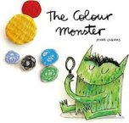 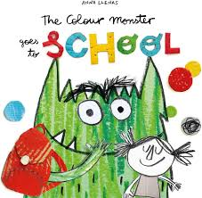





**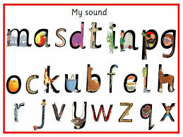

**Home learning:**

Your child will be bringing home a library book each week for you to share together at home. Once we have completed our baseline assessments, children will also bring home a sound blending book which matches their phonic knowledge. Please try to read at least 3 times a week at home. Books are changed weekly.

|  |  |  |
| --- | --- | --- |
| **Weekly reminders for Reception** | | |
| **Monday** | £1 snack |  |
| **Tuesday** |  |  |
| **Wednesday** |  |  |
| **Thursday** |  |  |
| **Friday** | Reading books changed |  |

**Some important reminders:**

* Please ensure **ALL** uniform items are **clearly labelled** with your child’s name.
* Snack money is £1 per week or £7 for the half term.
* Children should bring their book bag and water bottle each day. (Please **do not** send in rucksacks or large bags)
* As the weather turns cooler, please ensure children are dressed appropriately with a coat. We are outside in all weather!
* If you need to speak to your class teacher, please arrange an appointment at the school office for a mutually convenient time.
* For safety reasons, we ask parents to refrain from walking up the ramp at home time. Please wait at the bottom of the ramp for your child to be called by a staff member and sent out to you.

**Dates for your diary:**

INSET Day – Friday 25th October

Half Term – 28th October to 1st November

