**What it the Phonics Screening Check?**

The Phonics Screening Check is a quick and easy check of your child’s phonics knowledge. It helps the school confirm whether your child has made the expected progress and is on track to become a fluent reader.  It also helps to identify children who need extra help with phonics skills and reading. The national phonics screening check was introduced in 2012 to all Year 1 pupils in the country.

**When will the phonics screening take place?**

In 2024 the check will take place during the week commencing Monday 10th June 2024.

**How does the check work?**

Your child will sit one-on-one with a teacher in a quiet space.  The teacher will give your child a few practice words to read first so they understand what they have to do.  The check consists of a list of 40 words, half are real words and half are non-words (pseudo) words.  Each of the non-words is presented with a picture of a monster / alien, as if the word were their name (and so your child doesn't think the word is a mistake because it doesn't make sense!).

Your child will be asked to read the 40 words aloud. The test normally takes around ten minutes. If your child is struggling the teacher will stop the check. The check is carefully designed not to be stressful for your child.

The 40 words and non-words are divided into two sections – one with simple word structures of three or four letters, and one with more complex word structures of five or six letters.

**Why do the children need to read alien words?**

Non-words (or pseudo words, or alien words) are a collection of letters that follow the phonics rules your child has been taught, but don’t mean anything – your child will need to read these with the correct sounds to show that they understand the phonics rules behind them.  They are important to include as they can’t be read from memory; the children have to use their decoding skills.   It is your child’s decoding skills that are being checked.

**Does my child have to take the PSC?**

Yes – all students in Year 1 in England must take the Phonics Screening Check.

**Can I see an example PSC?**

Yes - you can download the Department for Education's official Year 1 Phonics screening check past papers to get an idea of what your child will be asked to do. [Click here](https://assets.publishing.service.gov.uk/government/uploads/system/uploads/attachment_data/file/621157/STA177753p_2017_phonics_screening_check_pupils__materials_-_standard.pdf) for the 2017 PSC

**Will I be told how my child did in the PSC?**

Yes - you will be told it your child did or did not achieve the expected standard, this will be included in your child’s school report in July.  If your child’s score falls below the standard, they will be given extra phonics help and will be required to re-take the Phonics Screening Check in Year 2.**ow can I help my child prepare?**

**How can I help my child?**

In school we have a phonics lesson every day.  We are continually checking your child’s phonic development and teaching the next steps.  However, there are a number of things that parents can do to support early reading skill development. Let your child see you enjoying reading yourself – they are influenced by you and what you value! Immerse your child in a love of reading: share books and magazines with your child, take them to the library to choose books, read to them regularly, point out texts around you, e.g. in the street etc. Make time for your child to read school books to you regularly – encourage them by pointing to the words and ask them about the story they are reading.

All children in Year 1 have been given QR codes to access online videos from our chosen phonics scheme RWI. Teachers have personalised these for your child by highlighting the sounds that your child was unsure of at the last assessment.  Go over the sounds with your child regularly and ensure that they can recall them all quickly and easily.  The RWI scheme we use in school splits the sounds into 3 sets.  The videos below show you how to pronounce the sounds.

Some short films from RWI to support parents;

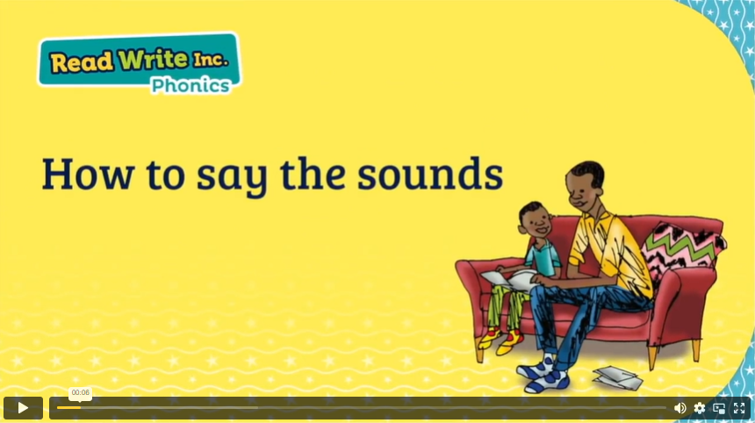

<https://schools.ruthmiskin.com/training/view/mO9bGVKK/tDGKszSI>

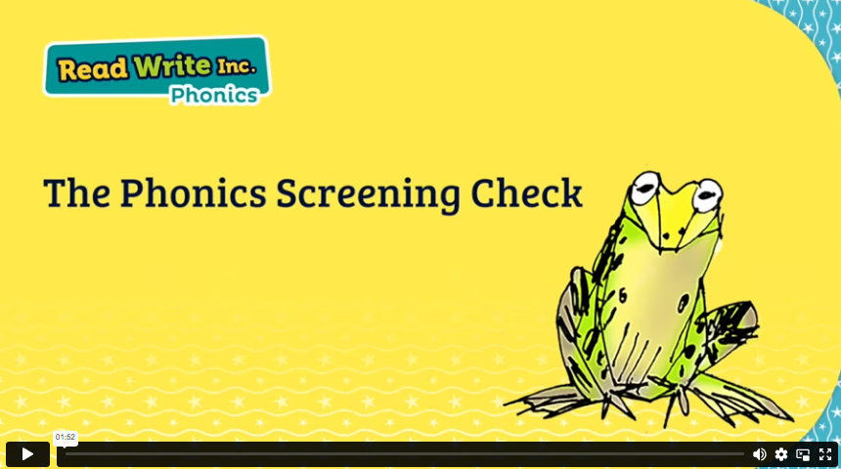

<https://schools.ruthmiskin.com/training/view/UKdKIY9D/XMt2jm5d>

Another online resource we would recommend to you is a free site that helps children to learn sounds through playing games. This site is called ‘Phonics Play’.  [Click here](https://www.phonicsplay.co.uk/) to visit the website.

At Linaker we are proud to say that last year the percentage of our children that passed the Phonics Screening Test exceeded the national average. This is because we have team of teachers and support staff that are experts in the teaching of phonics and reading. We have high expectations and aspirations for our children and we work in partnership with parents and carers.