**Mini Beast Hunt** 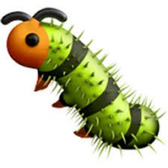

We went on a mini beast hunt in our outdoor classroom and found lots of clues that there had been some mini beasts!

Who could have nibbled this hole in the leaf?

Could it be The Woolly Bear Caterpillar?