**Year 2 Newsletter**Summer Term

**Books we are reading:**

Linaker English –

The King who banned the dark.

Rosie Revere Engineer

Linaker Reading –

The Great Fire

The Baker’s Boy and The Great Fire of London

The Great Fire of London

**Units of learning this half term:**

English – To write a letter and a banning narrative.

Maths – Addition and subtraction /Position and Direction/Multiplication and Division/Statistics

Science – Lifecycles / Master chefs

P.E. – Athletics / Net and Wall games / Team Building / Field games

PSHE – Relationships.

Art – How can we transform an object and turn it into sculpture, using our imagination? (3D Form)

History – Stone Age

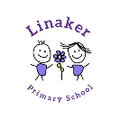

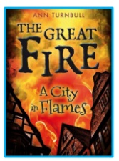

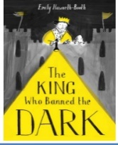

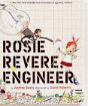

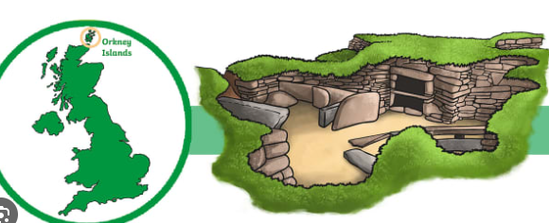

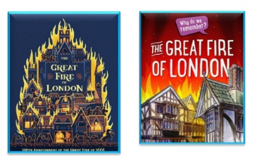

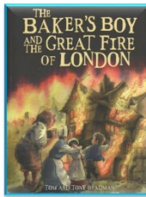

**Home learning:**

Daily Reading

Top marks (maths online programme)

Times table rockstars

**Useful websites:**

<https://www.topmarks.co.uk/>

[www.getset4education.co.uk](http://www.getset4education.co.uk)

|  |  |  |
| --- | --- | --- |
| **Weekly reminders for Year 2** | | |
| **Monday** | PE day |  |
| **Tuesday** |  |  |
| **Wednesday** | PE day |  |
| **Thursday** |  |  |
| **Friday** | Reading books to be changed in school |  |

Some important reminders:

* Please ensure children are bringing a water bottle to school every day.
* Reading books to be brought to school every day for reading.
* Correct uniform is required.